**Complex Network Analysis**

**Project User Manual**

**26.05.2013**



**09411018**

**Mehmet AKTAŞ**

[**maktasceng@gmail.com**](mailto:maktasceng@gmail.com)

https://github.com/maktas/GephiTest/tree/master/HiveplotModule

**Hiveplot Layout: A Short Manual**

**Hiveplot Layout: A Short Manual**

The *hive plot* is a rational visualization method for drawing networks. Nodes are mapped to and positioned on radially distributed linear axes — this mapping is based on network structural properties. Edges are drawn as curved links. Simple and interpretable.

The purpose of the hive plot is to establish a new baseline for visualization of large networks — a method that is both general and tunable and useful as a starting point in visually exploring network structure.

***Excerpt from hiveplot.com***

In this first implementation of Hiveplot Layout for Gephi I tried to create an input panel that lets users select one of the meaningful properties for the axis assignment and on-axis ordering properties. However, firstly the user has to run some statistics and press the Refresh button to have the newly generated columns on the combo boxes.

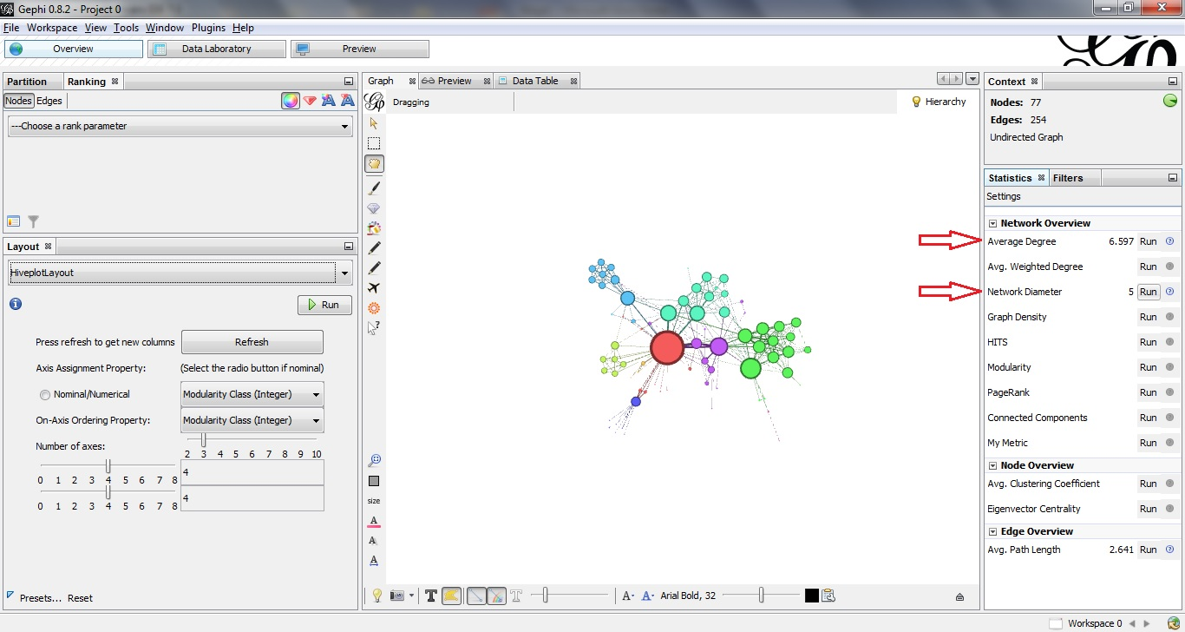

**Figure 1 –** Running Statistics in Gephi

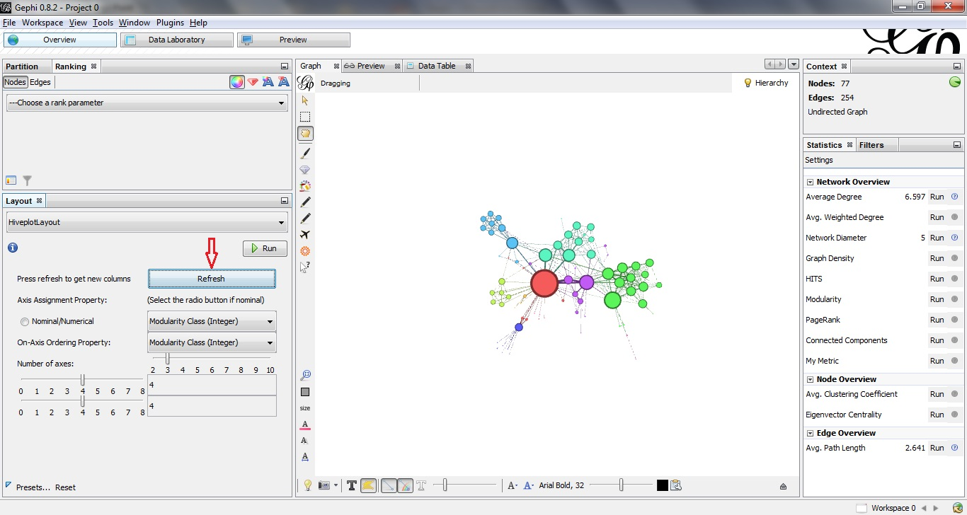

**Figure 2 –** Using Refresh Button to Fill Axis Assignment and On-Axis Ordering Combo Boxes

The user then selects the axis assignment property and on-axis ordering property.

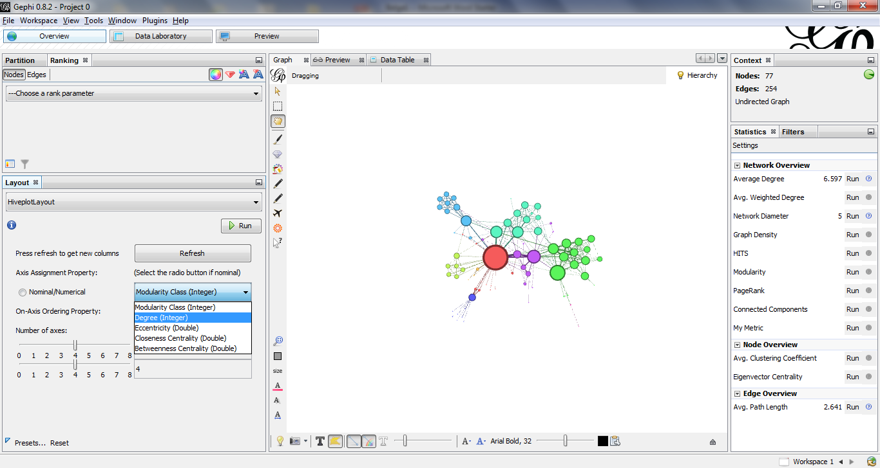

**Figure 3 –** Choosing Axis Assignment Property

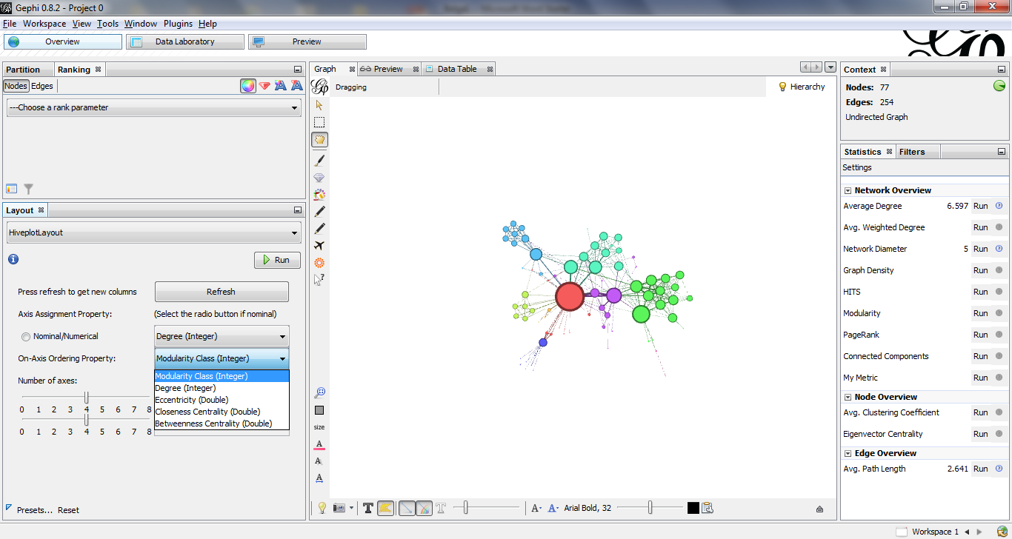

**Figure 4 –** Choosing On-Axis Ordering Property

Then s/he selects the number of axes from the slider.

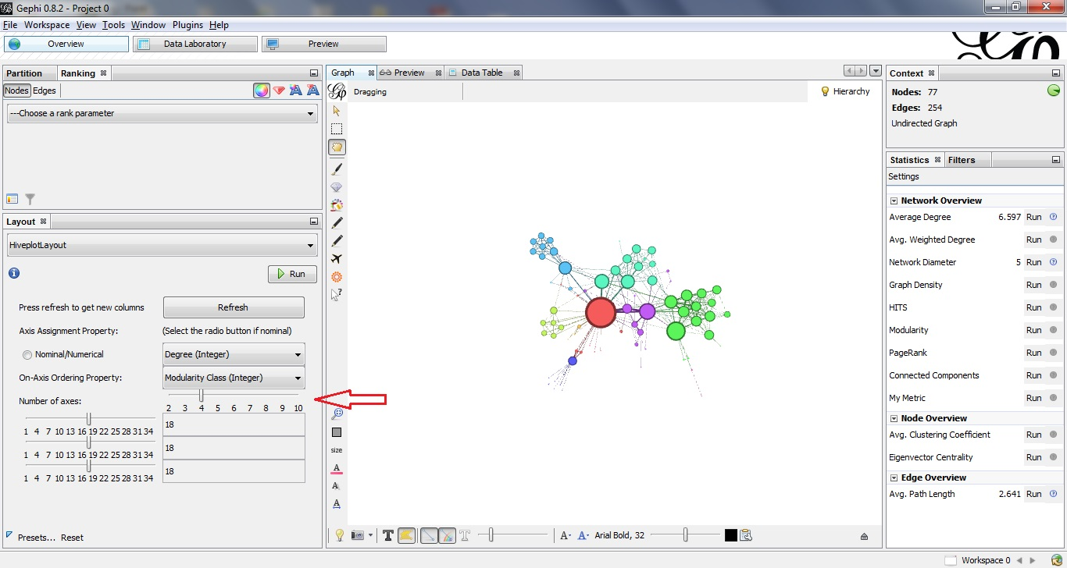

**Figure 5 –** Choosing Number of Axes

Then the user selects the parameters for the assignment accordingly.

For example if the user wants degree for axis assignment and modularity for on-axis ordering property s/he selects 'Degree' in the first combo box and if s/he wants 4 axes for the graph and that first axis containing nodes having degree less than 5, second axis between 5 and 10 and third axis between 10 and 20 and the fourth one greater than 20, s/he selects 4 in the number of axes slider, 5 in the first parameter input slider, 10 in the second parameter slider and 20 in the third input slider.

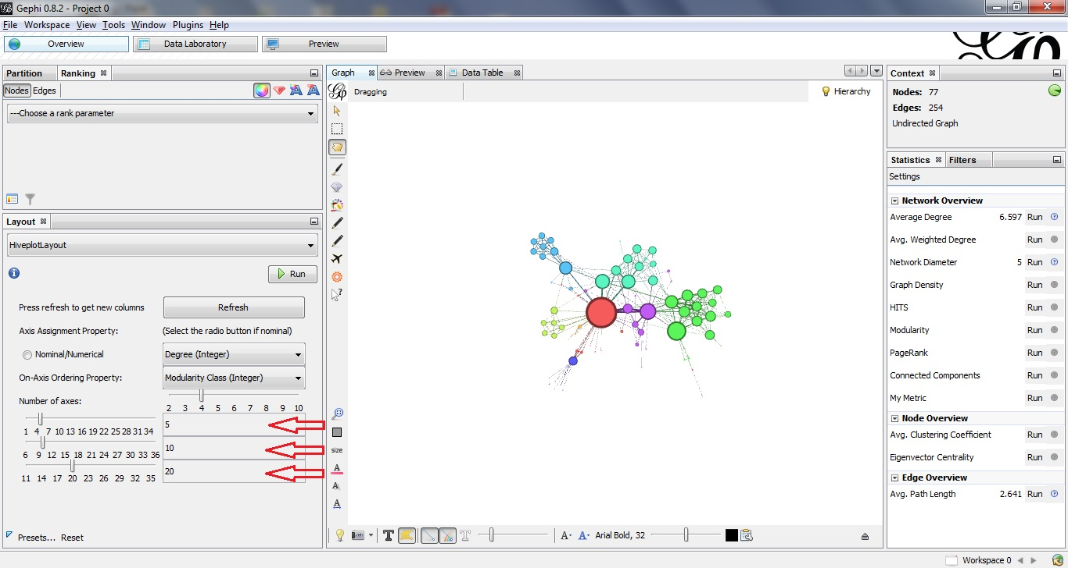

**Figure 6 –** Choosing Parameters from Input Sliders

Finally, the user clicks the run button to get the graph with hiveplot layout.

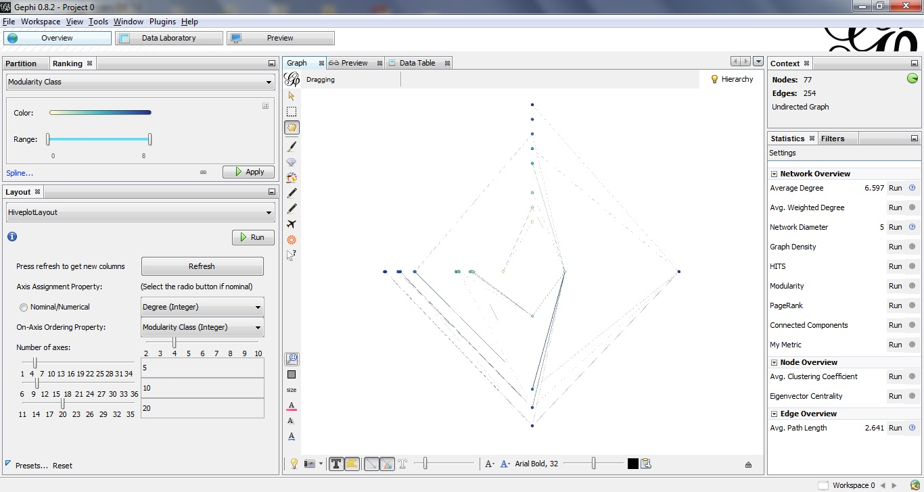

**Figure 7 –** After Running the Algorithm